6.91: From the chain rule, 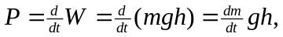 for ideal efficiency. Expressing the mass rate in terms of the volume rate and solving gives

